* We have to get the Veracode details such as the login and other details from the welcome email sent from the Veracode team.
* Once after we login, we have an option to create our own project for our demo analysis.
* After the registration of the Demo Project we would be able to run Demo-scanning.

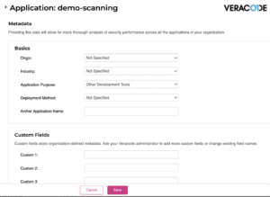

* Now the next step is to create an API key from the Veracode and then add it as part of the CICD using Azure DevOps.
* Click on the API Credentials and Generate the new code as part of the CICD process.

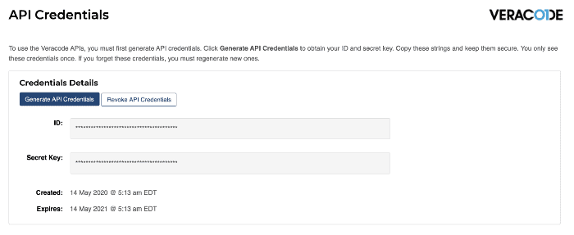

* Our next step is to create an Azure DevOps Plugin from the Marketplace.
* Include the Veracode task while creating the CI/CD Pipeline.

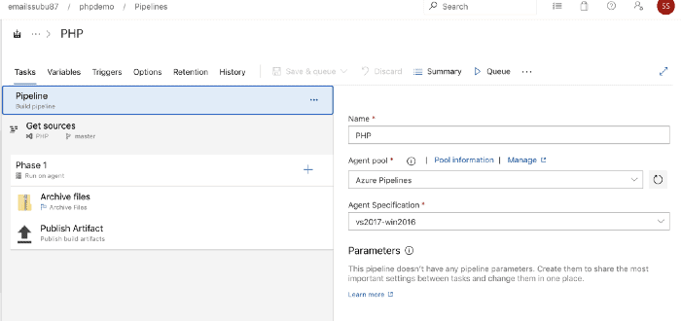

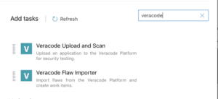

1. Next, we need to create a new Service Endpoint to integrate our Azure DevOps with Veracode.

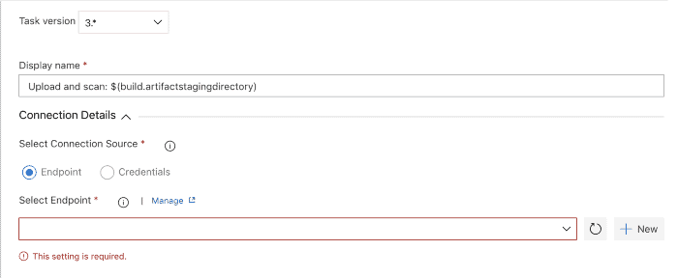

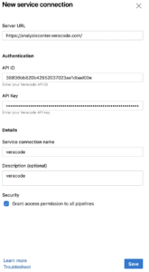

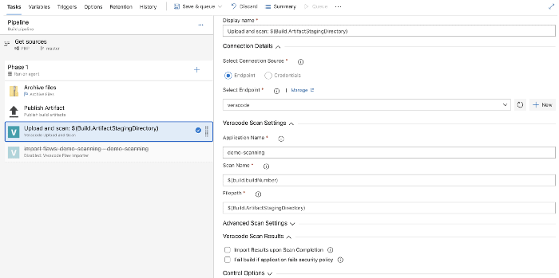

* We can Save and Run the Pipeline once the connection is setup.

The results of the Veracode Scan once complete can be checked on the Veracode Platform.

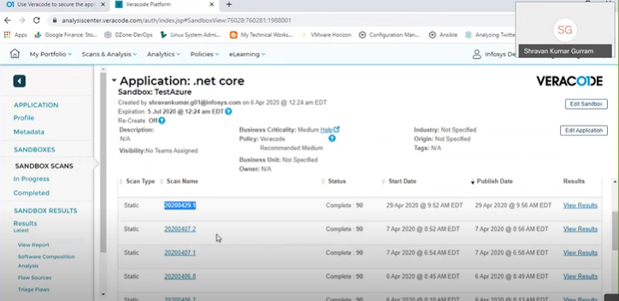

We can download the detailed report from the Veracode platform :

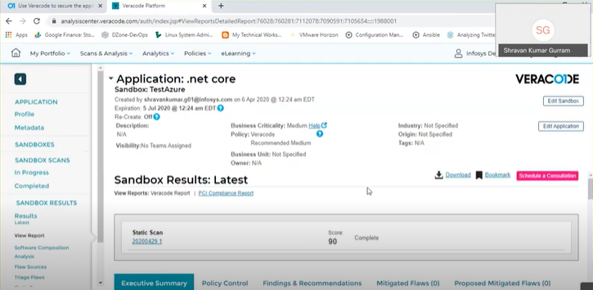

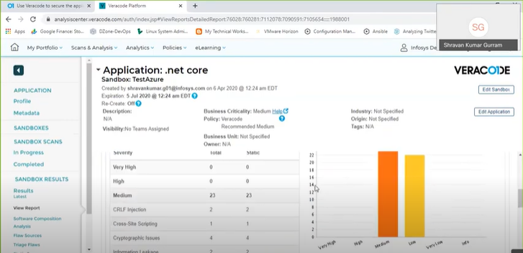

We can view Veracode Scan results from the Azure DevOps Pipeline as well :

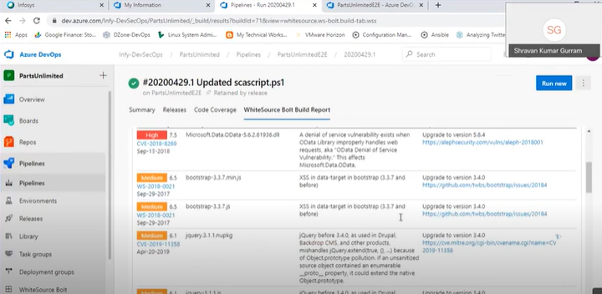

We can also publish the Vera code Scan report as part of the Pipeline artifact. The detailed Scan report can be downloaded from here.